

Researcher User Manual –

RESEARCH ASSISTANT MODULE

RESEARCH MANAGEMENT SYSTEM VERSION 2 (RMS V2)
Researcher User Manual Version 1.00

This document contains the Researcher User Manual for the IIUM Research Management System.

Htech Solutions Asia Pacific (M) Sdn. Bhd.

Document Control

General Information

Document Title | IIUM Research Management System - Researcher User Manual
Prepared For | Research Management Centre ,IIUM
Date Prepared | 1 March 2017
Update Date | 26 April 2017
Contract Reference
Version | 1.0 (Release)

Verification,Certification and Approval

Activity | Name/Position | Signature | Date
Prepared By | Mohd Nazri Amdan  Junior System Analyst  Htech Solutions
Prepared By | Fakhrul Azman Ali  System Analyst  Htech Solutions
Reviewed By | Zuliana Zubir  Lead Technical  RMC, IIUM

Revision Log

Version | Date | Description
0.1 | 1 Mar 2017 | First Draft Release
0.2 | 15 Mar 2017 | Second Draft Release
1.0 | 25 Apr 2017 | First Release (User Sign Off)

TABLE OF CONTENTS
TABLE OF CONTENTS 4
Introduction 5
Purpose 6
Target Audience 6
Login 6
DashBoard 6
Researcher - Profile 7
Follow the steps below to access the profile. 8
Step 1. Click on Profile on the side menu. Researcher’s Profile can be viewed only. 8
Researcher - Request Submission Error! Bookmark not defined.
Research Assistant Application 9
Application - New Appointment (for Researcher) 9
Step 1. Click on Request Submission on the side menu and select Research Assistant Application from the research drop down. 9
Step 2. Select the research project. 9
Step 3. Select Appointment Type 10
Step 4. Select Research Assistant Type 10
Step 5. Click button located at the bottom to proceed. 10
Step 6. Click button or button to navigate through the application form. 10
Step 7. Select Appointment Status 11
Step 8. Search Student or Vendor 11
Step 9. Fill in Application Information 11
Step 10. Upload required files document 12
Step 11. Save as Draft or Submit Application 12
Application - New Appointment (for Student/Vendor - via Email) 13
Step 1. Upon completed, you will get an Offer Letter through email. 14
Application - Extension (for Researcher) 15
Step 1. Click on Request Submission on the side menu and select Research Assistant Application from the research drop down. 15
Step 2. Select the research project. 15
Step 3. Select Appointment Type 15
Step 4. Click button located at the bottom to proceed. 16
Step 5. Select Student or Vendor you want to extend 16
Step 6. Fill in Extension information 17
Step 7. Upload files document 17
Step 8. Save as Draft or Submit Application 17
Application - Extension (for Student/Vendor - via Email) Error! Bookmark not defined.
Step 1. Upon completed, you will get an Extension Letter through email. 19
Application - Termination(for Researcher) Error! Bookmark not defined.
Step 1. Click on Request Submission on the side menu and select Research Assistant Application from the research drop down. 20
Step 2. Select the research project. 20
Step 3. Select Appointment Type 20
Step 4. Click button located at the bottom to proceed. 21
Step 5. Select Student or Vendor you want to terminate 21
Step 6. Fill in Termination information 21
Step 7. Upload files document 22
Step 8. Save as Draft or Submit Application 23
Application - Termination(for Student/Vendor - via Email) 24
Step 1. Upon completed, you will get an Termination Letter through email. 24
Application - Termination(for Researcher) 25
Step 1. Click on Request Submission on the side menu and select Research Assistant Application from the research drop down. 25
Step 2. Select the research project. 25
Step 3. Select Appointment Type 25
Step 4. Click button located at the bottom to proceed. 26
Step 5. Select Student or Vendor you want to withdraw 26
Step 6. Fill in Withdraw information 27
Step 7. Upload files document 27
Step 8. Save as Draft or Submit Application 28

Introduction

Purpose

This document cover how to use the Research Management System Version 2 (RMSV2) - Researcher User Manual

Target Audience

The target audiences for this User Manual include:-
- Researchers
- Research Management Center Officers

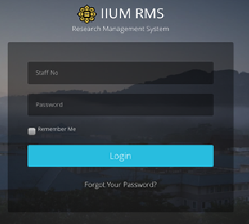
Login
In a web browser, enter the following address:-

https://rmsv2.iium.edu.my

In the screen, enter your valid HURIS username
and password, Then click the LOGIN icon as depicted on screen.

DashBoard
This is the first screen display when user successfully login to the system.

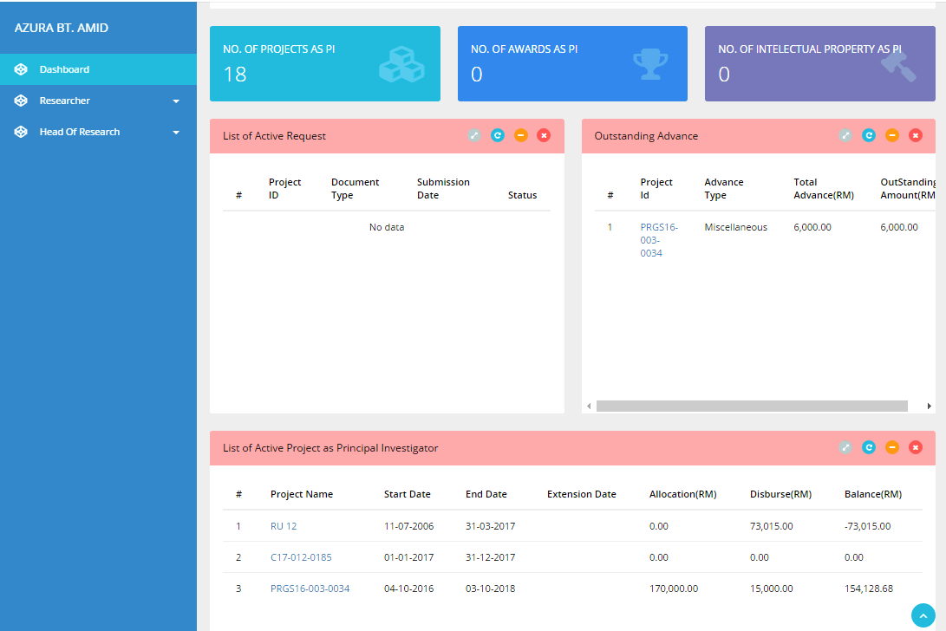
The Dashboard consist of
- Menu on the left
- Information Summary for the user such as
  - Number of projects as Principal Investigator
  - No of awards received as Principal Investigator
  - No of Intellectual Properties registered by Principal Investigator
  - List of request(s) submitted pending for further actions
  - Outstanding Advancement
  - List of Active Project as Principal Investigator

Researcher - Profile
Researcher Information is extracted from HURIS. This data is ‘read only’ information. If there is any discrepancy, please contact MSD directly.

Follow the steps below to access the profile.

Step 1. Click on Profile on the side menu to view researcher’s profile. 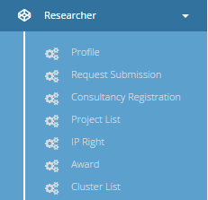

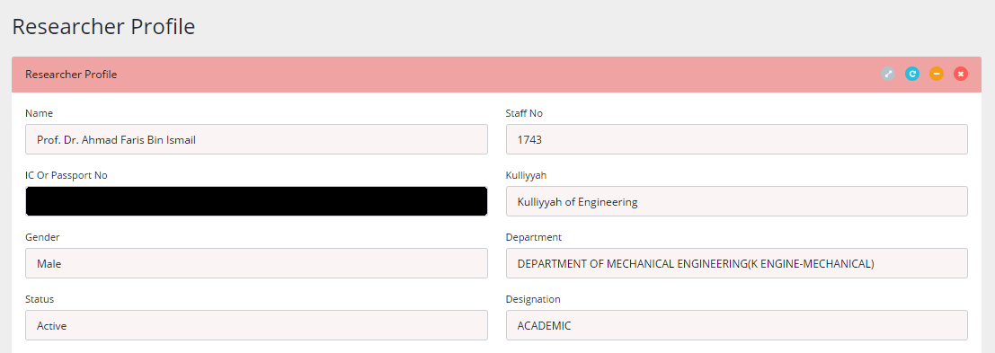

Researcher - Request Submission

Research Assistant Application

Research Assistant Application is further divided into
- New Appointment - To appoint new researcher assistant
- Extension for existing research assistant
- Termination of research assistant

Application - New Appointment (to be filled up by principal investigator)

Step 1. Click on Request Submission on the side menu and at ‘Research’ drop down menu, select Research Assistant Application.

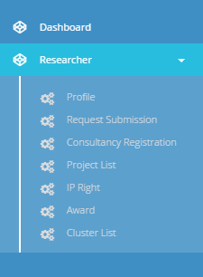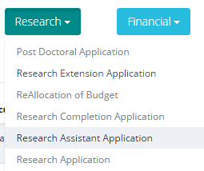

Step 2. Select the research project.
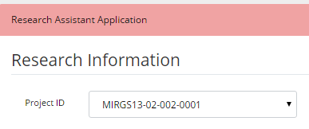

Step 3. At ‘Appointment Type’, select “New” from the list of options

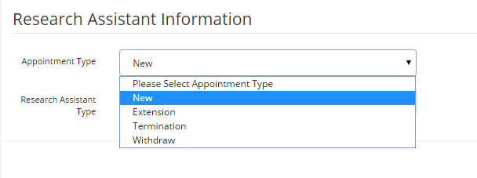

Step 4. At ‘Research Assistant Type’ :
- Select “Graduate Research Assistant” if the student is a Postgraduate (PhD or Master’s); or
- Select “Research Assistant” if the student is an Undergraduate

.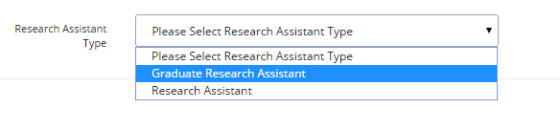
- For projects under PRGS grant, please select “Research Officer” at Research Assistant Type.
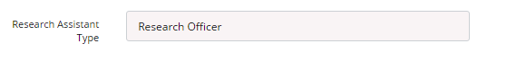
Step 5. Click button located at the bottom to proceed.
- Your application will be saved as draft
- You can edit or delete your draft application anytime at ‘Request Submission’ menu.
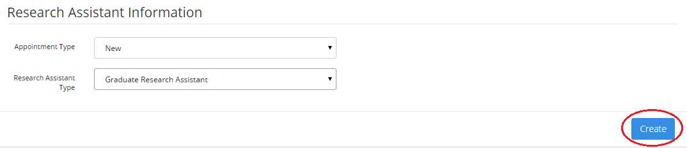

Step 6. Click button orbutton to navigate through the application form.
- Click ‘next’ to proceed
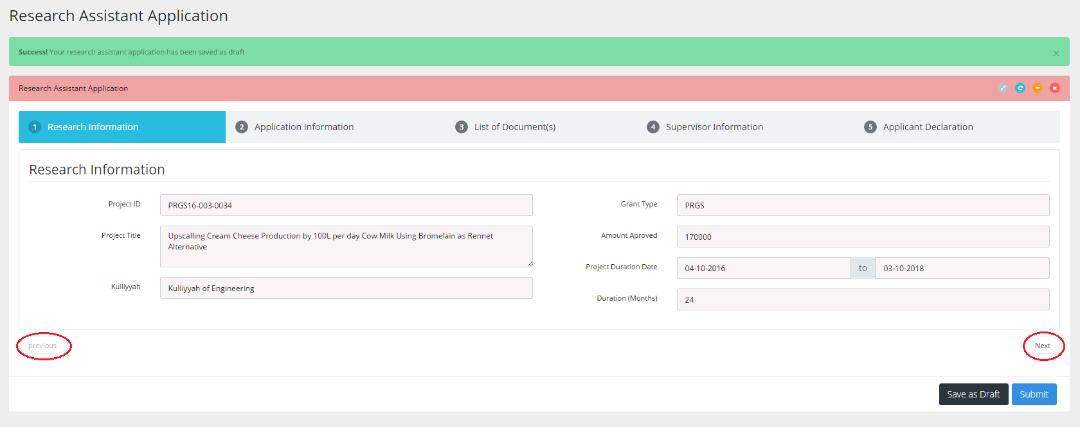

Step 7. Select Appointment Status
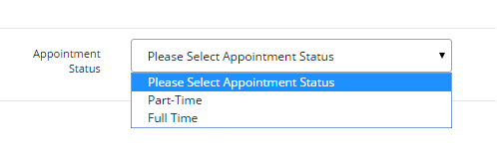

Step 8. Search Student or Vendor
- For GRA or RA, type in matric number in the ‘Student Matric No’ text field as shown below, then click  button. Details of student will appear.
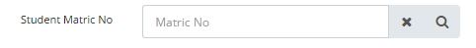

- For Research Officer (RO), type in vendor code in the ‘Vendor Code’ text field as shown below, then click button. List of vendors will appear then select one vendor. Details of vendor will appear.

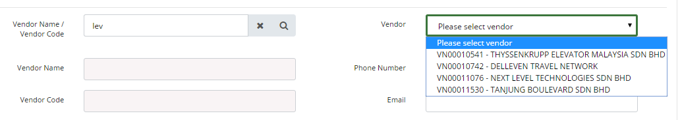

Step 9. Fill in Application Information
- Fill in student or vendor telephone number and email, if blank.
- Fill in ‘Duration of Appointment’. Note that end date of appointment MUST NOT EXCEED expected completion date of project.
- Fill in rate of payment.
- Click button to proceed.

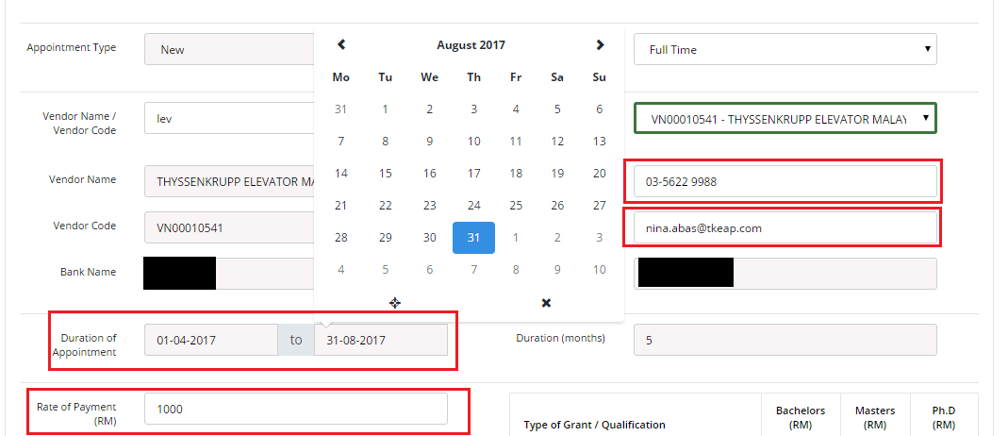

Step 10. Upload required files document
- Upload all required documents for the application. 1 file per item, maximum size per file is 1MB. Maximum is 5 files.
- Click button to proceed.
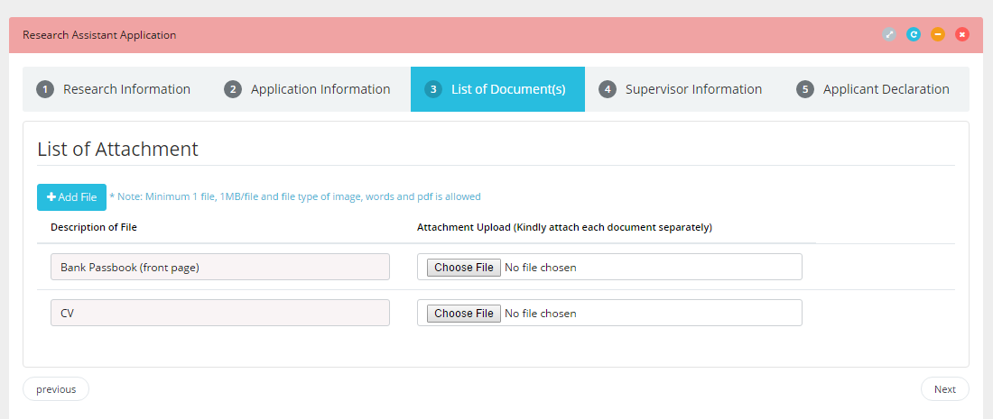

Step 11. Save as Draft or Submit Application
- Click  button to save application and edit later.
- Tick ‘Declaration’ box as shown below.
- Click  button to submit application for approval process.

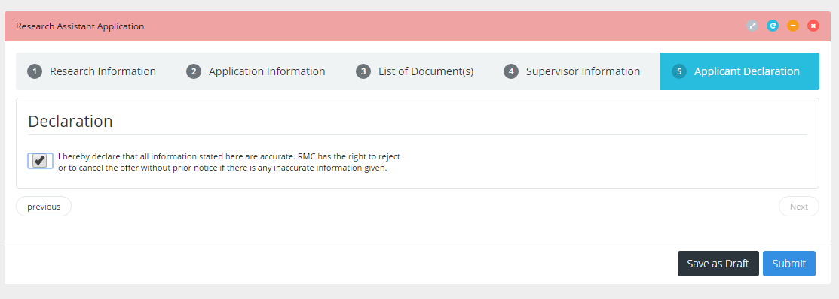

Application - New Appointment (for Student/Vendor - via Email)

Step 1. Upon approval, you will get an Offer Letter through email.
- Please click the link in the email to verify your appointment.

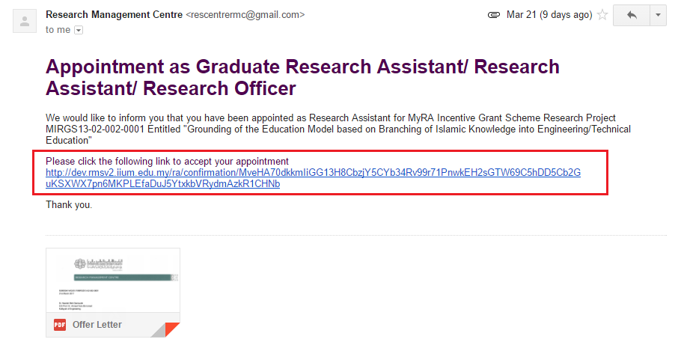

- Once verified, you will get another email on appointment as Research Assistant/Research Officer.
- Do follow instructions in the email.

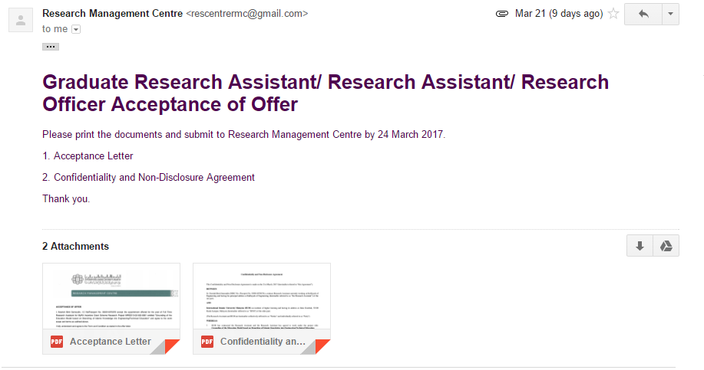

Application - Extension (for Researcher)

Step 1. Click on Request Submission on the side menu and at ‘Research’ drop down menu, select Research Assistant Application.

Step 2. Select the research project.

Step 3. At ‘Appointment Type’, select “Extension” from the list of options
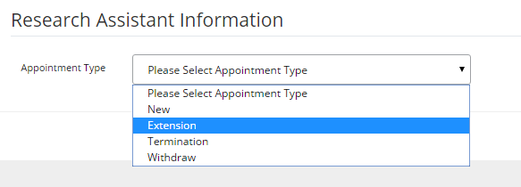

Step 4. Click button located at the bottom to proceed.
- Your application will be saved as draft
- You can edit or delete your draft application any time at ‘Request Submission’ menu.

Step 5. Select Student or Vendor you want to request for extension
- Click button to proceed.
- Select matric number of the student or vendor code from the list available as shown below. Details of Research Assistant will appear.
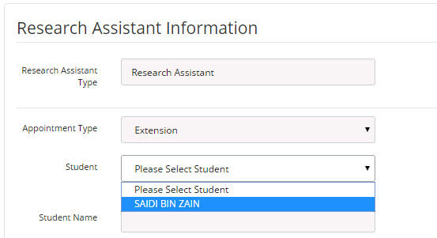

Step 6. Fill in Extension information
- Fill in student or vendor telephone number and email, if blank.
- Enter new end date for Research Assistant.
- Enter any changes for rate of payment.
- Click button to proceed.
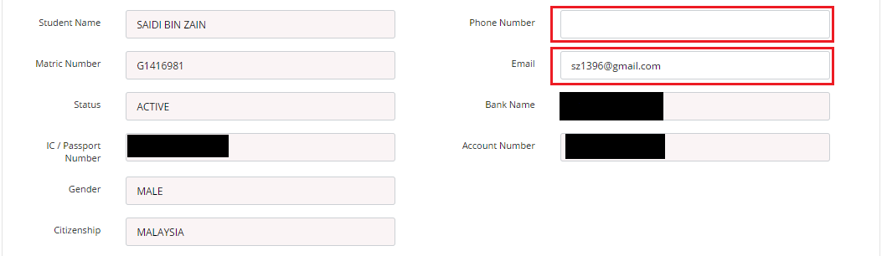

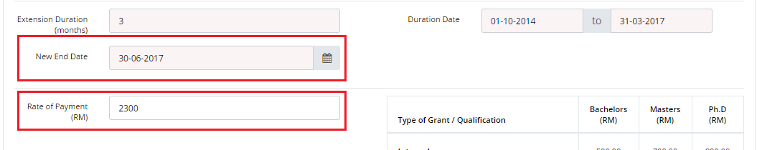

Step 7. Upload files document
- Upload document(s), if applicable. 1 file per item, maximum size per file is 1MB. Maximum is 5 files.
- Click button to proceed.
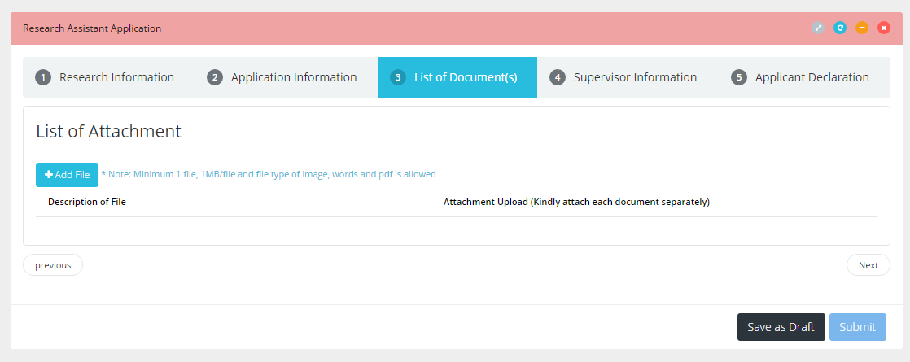

Step 8. Save as Draft or Submit Application
- Click button to save application and edit later.
- Tick ‘Declaration’ box as shown below.
- Click button to submit application for approval process.
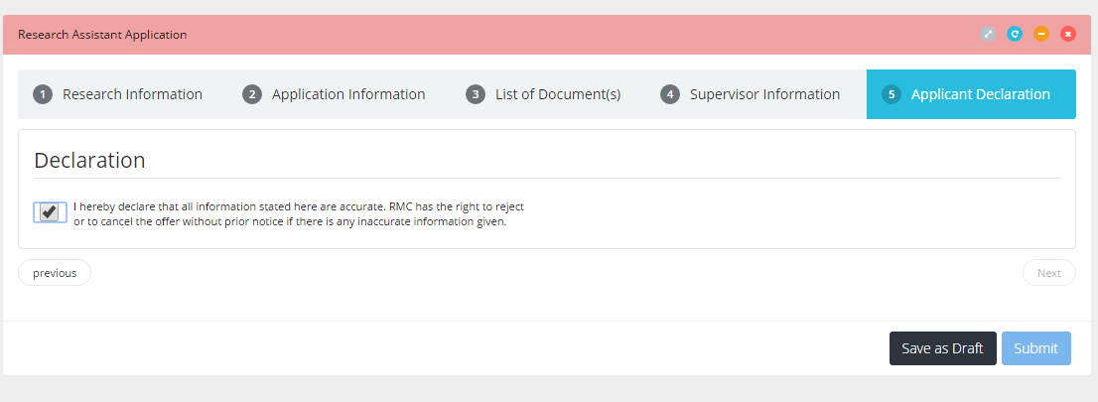

Application - Extension (for Student/Vendor - via Email)

Step 1. Upon approval, you will get an Extension Letter through email.

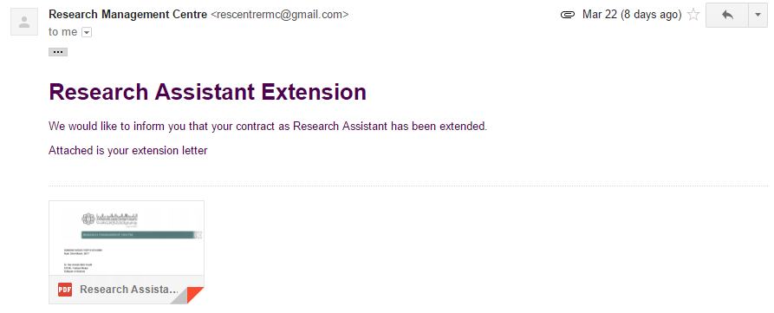

Application – Termination (for Researcher)

Step 1. Click on ‘Request Submission’ on the side menu and at ‘Research’ drop down menu, select Research Assistant Application.

Step 2. Select the research project.

Step 3. At ‘Appointment Type’, select “Termination” from the list of options
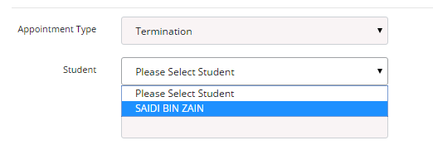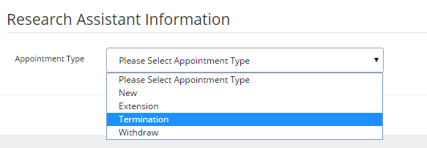

Step 4. Click button located at the bottom to proceed.
- Your application will be saved as draft
- You can edit or delete your draft application at ‘Request Submission’ menu.

Step 5. Select Student or Vendor you want to terminate
- Click button to proceed.
- Select matric number of the student or vendor code from the list available as shown below. Details of Research Assistant will appear.

Step 6. Fill in Termination information
- Fill in student or vendor telephone number and email, if blank.
- Enter Effective Date by using ‘date picker’.
- Fill in Justification.
- Click button to proceed.

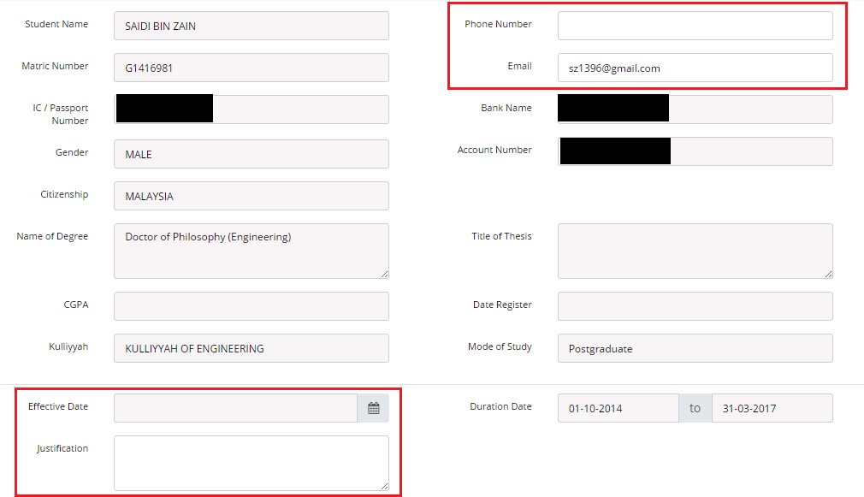

Step 7. Upload files document
- Upload document(s) if applicable. 1 file per item, maximum size per file is 1MB. Maximum is 5 files.
- Click button to proceed.

Step 8. Save as Draft or Submit Application
- Click button to save application and edit later.
- Tick ‘Declaration’ box as shown below.
- Click button to submit application for approval process.

Application – Termination (for Student/Vendor - via Email)

Step 1. Upon approval, you will get Termination Letter through email.

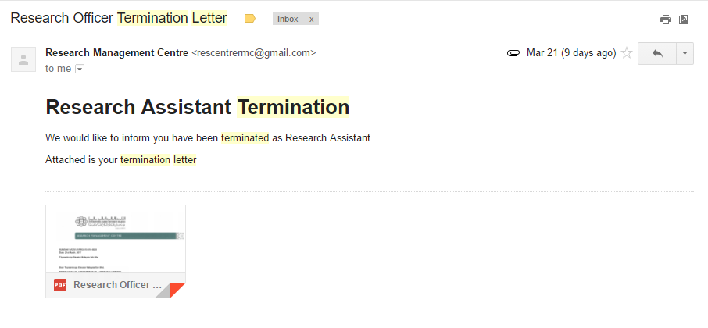

Application – Termination (for Researcher)

Step 1. Click on ‘Request Submission’ on the side menu and at ‘Research’ drop down menu, select Research Assistant Application.

Step 2. Select the research project.

Step 3. At ‘Appointment Type’, select “Withdraw” from the list of options
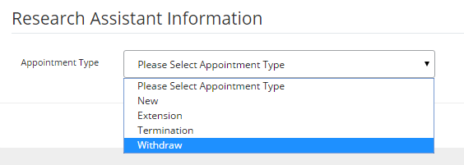

Step 4. Click button located at the bottom to proceed.
- Your application will be saved as draft
- You can edit or delete your draft application at ‘Request Submission’ menu.

Step 5. Select Student or Vendor you want to withdraw
- Click button to proceed.
- Select matric number of the student or vendor code from the list available as shown below. Details of Research Assistant will appear.
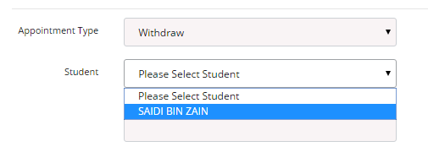

Step 6. Fill in Withdraw information
- Fill in student or vendor telephone number and email, if blank.
- Enter Effective Date by using ‘date picker’.
- Fill in Justification.
- Click button to proceed.

Step 7. Upload files document
- Upload files document if necessary. 1 file per item, maximum size per file is 1MB. Maximum is 5 files.
- Click button to proceed.

Step 8. Save as Draft or Submit Application
- Click button to save application and edit later.
- Tick ‘Declaration’ box like shown below.
- Click button to submit application for approval process.

Step 9. Upon approval, you will get Withdrawal Letter through email.

