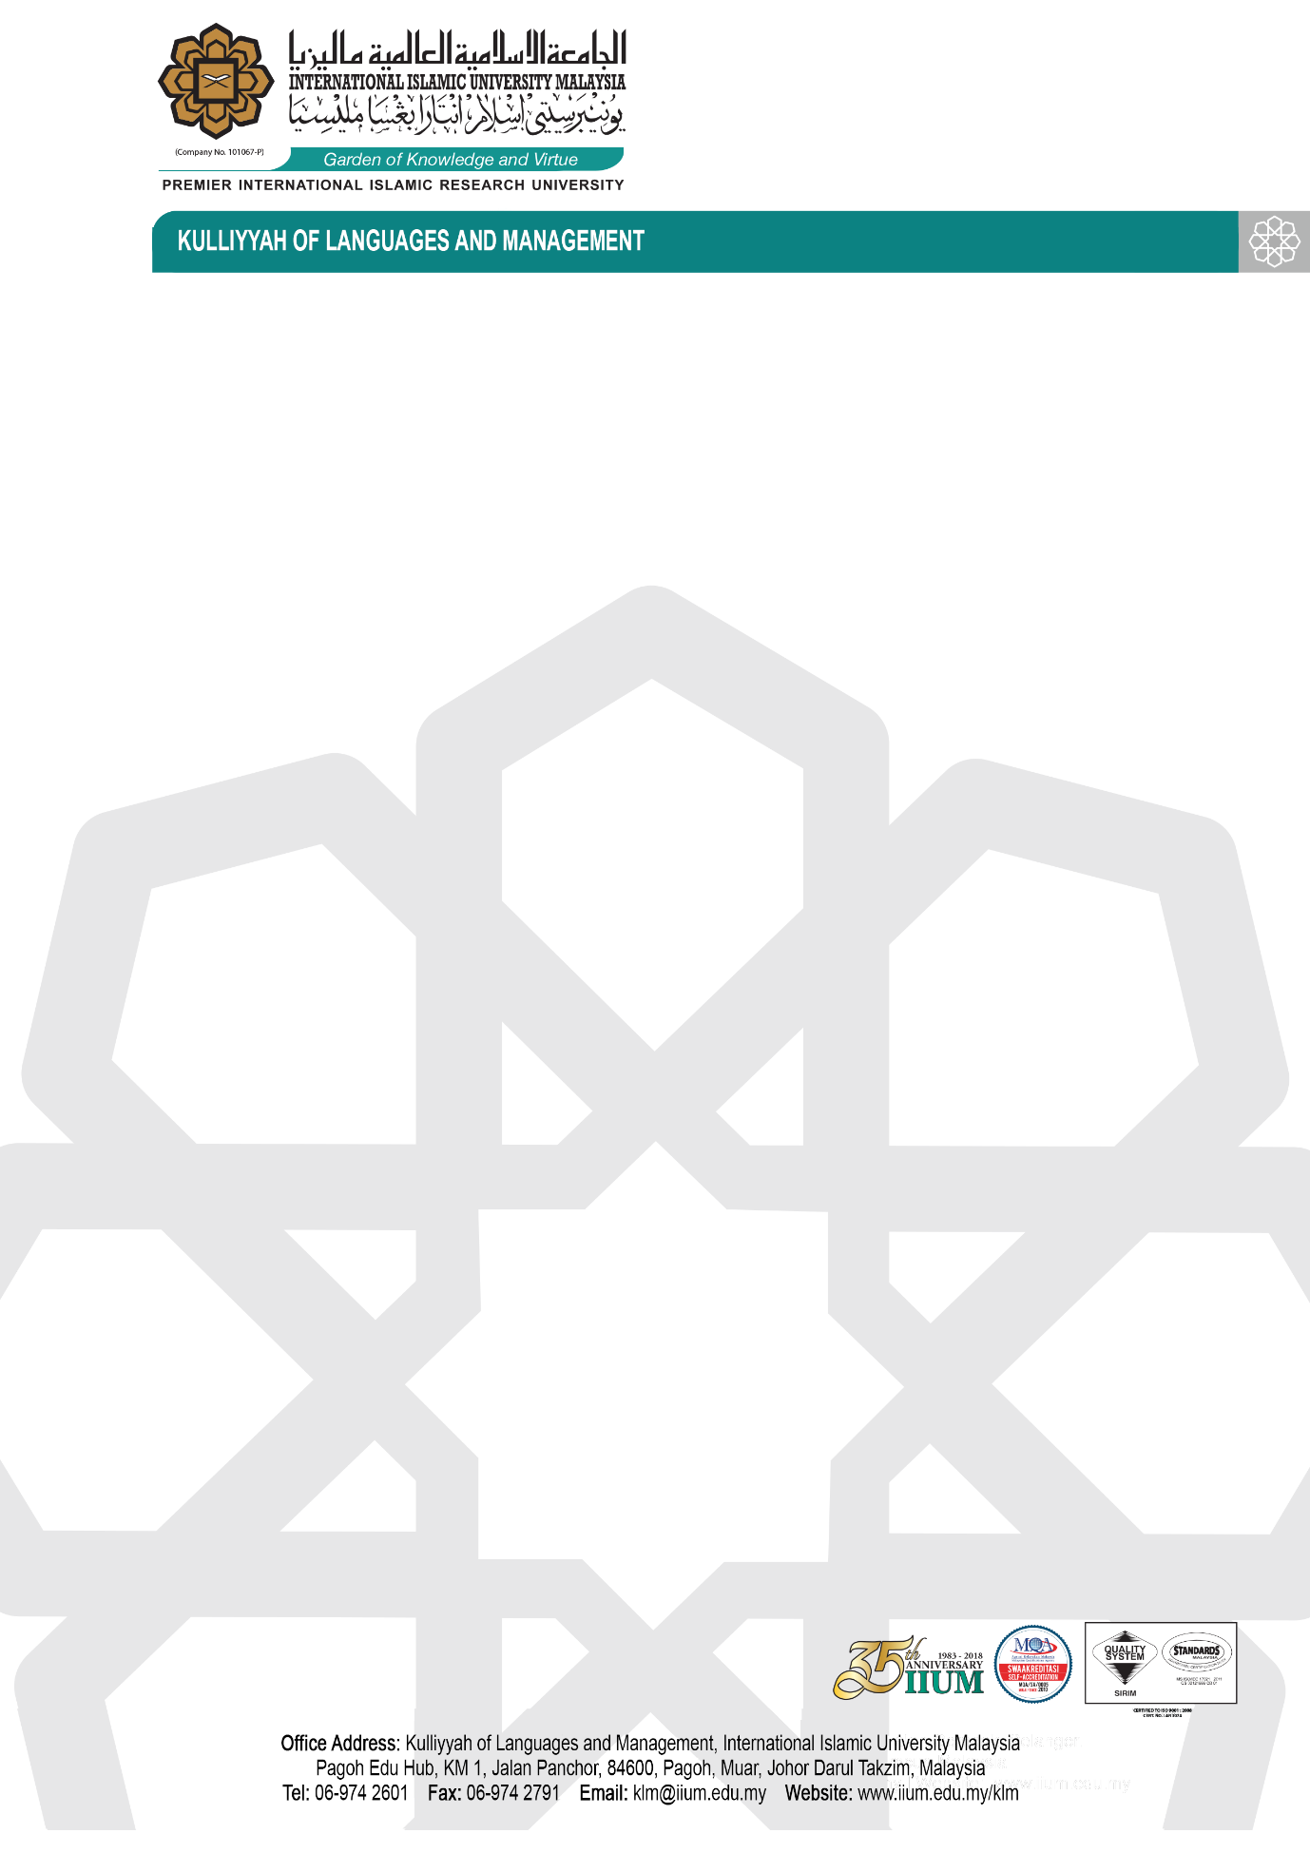

Our Ref : IIUM/316/10/7/2
Date :

COMPANY NAME

QUOTATION FOR : -

You are invited to participate in the above quotation. The details are as follows:

NO | SPECIFICATION | QUANTITY

For information, inquiry implies no obligation on the part of the university. If substitutes are offered, please make full explanation. We reserve the right to reject any or all bids and/or to accept the most attractive offer and to accept any items or combination of items in the above bids. The University is not bound to accept the lowest offer. Please submit the relevant catalogues or sample, if necessary.

Kindly write at right hand corner of the envelope “QUOTATION FOR-”. This quotation must be submitted in a sealed envelope before 12.00 p.m on - at - .

Nonetheless, please be reminded on the following clause:-

- Any act or attempt to corruptly offer or give, solicit or receive any gratification to and from any person in connection with this procurement is a criminal offence under the Malaysian Anti-Corruption Commission Act 2009 (Act 694).

ii) If any person offers or gives any gratification to any members of the public service, the latter shall at the earliest opportunity thereafter lodge a report at the nearest office of the Malaysian Anti Corruption Commission Agency or police station. Failure to do so is an offence under the Malaysian Anti-Corruption Commission Act 2009 (Act 694).

iii) Without prejudice to any other actions, disciplinary action against a member of the public service and blacklisting of the contractor or supplier may be taken if the parties are involved with any act of corruption under the Malaysian Anti-Corruption Commission Act 2009 (Act 694 ).

iv) Any contractor or supplier who makes a claim or payment in relation to this procurement although no work was carried out or no goods were supplied or no services rendered in accordance with the specifications and any member of the public service who certifies the claim commits an offence under the Malaysian Anti-Corruption Commission Act 2009 (Act 694).

If you have any inquiries please do not hesitate to call ------------------ for further information.

Thank you.

______________________________________
HOD / Deputy Director
Kulliyyah of Languages and Management
International Islamic University Malaysia

